## **Ideation Phase**

**Define the Problem Statements**

|  |  |
| --- | --- |
| Date | 21 June 2025 |
| Team ID | LTVIP2025TMID20459 |
| Project Name | Docspot |
| Maximum Marks | 2 Marks |

**Customer Problem Statement**

* **Who is experiencing the problem?** Freelancers—both newcomers and experienced professionals—across various domains such as design, writing, tech, and marketing.
* **What are they trying to accomplish?** They aim to find legitimate, relevant, and well-paying freelance jobs quickly and efficiently, without spending excessive time sorting through spam or low-quality listings.
* **What is standing in their way?**
* Overcrowded platforms with inconsistent filtering and irrelevant job results
* Scam listings or jobs with unclear expectations and poor compensation
* Delayed response times and lack of client transparency
* Difficulties in establishing trust and showcasing portfolios effectively
* Competitive saturation leading to underbidding wars
* **How are they currently addressing this issue?**
* Subscribing to multiple freelance platforms and manually sifting through listings
* Using job aggregators, which often lead to outdated or duplicate listings
* Joining social media or niche communities that may lack structure or security

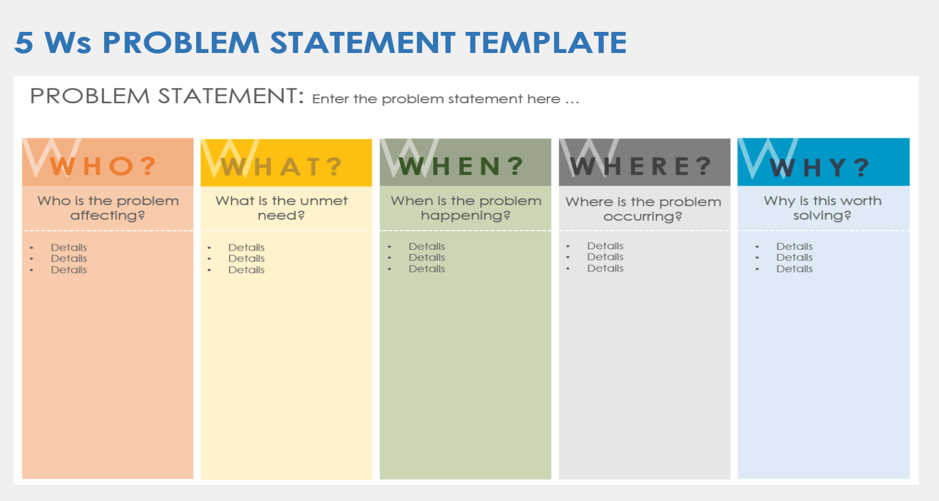

|  |  |  |  |  |  |
| --- | --- | --- | --- | --- | --- |
| **Problem Statement (PS)** | **I am (Customer)** | **I’m trying to** | **But** | **Because** | **Which makes me feel** |
| PS-1 | a working professional with a tight schedule | book a doctor’s appointment quickly without phone calls or long wait times. | most clinics don’t have real-time booking systems or clear availability info | their systems are outdated or fragmented | frustrated and anxious about my health getting worse while waiting. |
| PS-2 | a general physician running a small clinic. | manage patient bookings efficiently and reduce no-shows. | my current tools are manual or not tailored to healthcare workflows. | I cannot afford or understand complex clinic manageme-nt systems. | stressed and underpaid despite my busy schedule. |